



Administrative Services

Policies, Procedures and Guidelines Manual

Division of Business and Financial Affairs

***STANDARDS OF EXCELLENCE***

***CIVILITY, COMMITMENT, CONSISTENCY***

TABLE OF CONTENTS

Procurement Services Administrative Policy 1

Objective 1

Policy 1

Conflict of Interest 1

Code of Ethics/Conduct 2

Centralized Procurement 2 Administrative Services 2

Purchases Supported by College Policies 3

Contract Purchases 3

Unauthorized Purchases 4

Vendor Procurement Procedures and Selection 4 Vendor Profile/Guest Lecturer 4

Vendor/Independent Contractor 4

Vendor Profile for International Businesses 5

Vendor Selection/Preferred Vendor List 5 Banner Electronic Requisition 5 Banner Tutorial 6

Service Agreement 6

The Procurement Components 6

Competitive Bidding 7

Independent Contractors/Consultants 8

Independent Contractor Checklist 9

In Stock Inventory 11

Quality 11

Purchases Prohibited by College: Personal Items/Gift Cards 11

Gifts and Gratuities 11 Preplanning Purchasing Transactions 11

Emergency Buying 12

Special Procurement Policies 12

Flower Purchases 12

Rented/Lease Equipment 12

Outside Printing 13

College Letterhead, Envelopes and Business Cards 13

Prepaid Orders 13

Customized Purchases 13

Cellphone Services 14

The Purchase of Cars, Golf Carts 14

Motor Coach Policy 14

Product Licensing Policy 14

Legal Issues/Documents 14

Sales Tax/Tax Exempt Status 14

Year End Notification 15

Equipment Asset Management 15

Mail Services 15

Copy Services 15

Grant Related Procurement 16

Exhibit A: Code of Conduct 17

Exhibit A1: Supplier Code of Conduct 19

Exhibit B: Vendor Profile Form 21

Guest Speaker Form Exhibit C: Vendor/Independent Contractor Form 24

TABLE OF CONTENTS (continued)

Exhibit D: Electronic Banner Requisition 29

Exhibit E: Purchase Order (Example Only) 30

Exhibit F: Motor Coach 31

Exhibit G: Product Licensing 32

Exhibit H: Flowchart for the Procurement of 33 Goods and Services

Exhibit I: Resource List 34

Exhibit J: Independent Contractor Agreement 35 Exhibit K: Check Request Process 38

Exhibit L: Disposition of Fixed Assets 40

**PROCUREMENT SERVICES**

**ADMINISTRATIVE POLICY**

***Revised February 2014***

**Objective**

The objective of the Department of Administrative Services in the Division of Business and Financial Affairs is to leverage the buying power through contract negotiations, supplier management, and technology adoptions, which supports and defines cost savings, service, quality, and best overall value.

**Policy**

The procurement of goods and services applies to all restricted or non-restricted funds of the College. All funds are considered College funds and therefore must adhere to the College’s policy. Departments are allocated funds in their budgets for a designated period; however, departments are **NOT AUTHORIZED** to make purchases without a Banner generated/approved purchase order from Procurement Services, in the Department of Administrative Services. All requests must be authorized through the College’s electronic requisition system (BANNER). This is the first step that must be completed to acquire a College purchase order for goods/services.

The College also encourages the purchase of recycled items when possible. This initiative supports the College’s sustainability efforts that promote a greener environment. The purchase of all appliances on campus must also comply with the “Energy Star” rating.

It is against College policy to procure goods and services without an approved Banner generated purchase order number. It is also against Policy to use an invoice that has been received after the goods and services were acquired to generate a requisition. Failure to adhere to this Policy could result in non-payment to the vendor and could become the responsibility of the individual to pay the vendor.

It is the policy of the College that the following individuals have contract signing authority (new or cancellation of contracts) that obligates the College:

* President of the College
* VP for Business and Financial Affairs and Treasurer
* Associate VP for Business and Financial Affairs (if designated)
* Director of Administrative Services (if designated)

**Conflict of Interest**

|  |
| --- |
| To avoid conflict of interest, the College will not contract the purchase of property, (intellectual, real or personal), supplies, services, and/or equipment from employees of the College, or their immediate family or members of the Board of Trustees. The College will not contract with any vendor or independent contractor (including subcontractors or sub recipients), expressly including for participation in any federally funded research project, if the vendor or independent contractor does not agree to comply with the College’s Conflict of Interest Policy. The purpose of this requirement is to ensure that no one contracting with the College or participating in a federally funded research project with the College has a significant conflict of interest as that term is defined in the Policy that could damage the College or affect the design, data or conclusions of the research project. The link below will connect you to the College’s Conflict of Interest Policy. <http://princess.spelman.edu/vendorprofile.nsf/COI%20Policy?OpenPage> |

**Code of Ethics/Conduct**

Employees conducting business on behalf of Spelman College shall at all-time remain professional and conduct business in a professional manner and adhere to the College’s Code of Conduct. (**See Exhibit A**) Vendors doing business with the College will be held to the same standards. See Supplier/Vendor Code of Conduct (**See Exhibit A-1**)

**Centralized Procurement**

The centralized department for procurement, Administrative Services, is responsible for negotiating procurement needs and administering procurement policies and procedures. A centralized procurement function dictates that all purchases made should have a purchase order, which is generated from the College’s Banner financial system. Spelman College does not operate in a decentralized environment.

**The Department of Administrative Services**

Procurement Services procures goods and services on behalf of the College. The Director and the Manager of Procurement Services are authorized to manage the procurement department and are responsible for ensuring that the College’s objectives as well as the specific needs of user departments are met.

Procurement Services performs the following functions on behalf of the College:

1. Develops guidelines for purchasing supplies, services and equipment
2. Executes and develops service agreements with user departments
3. Works with the VP of Business and Financial Affairs and Treasurer on negotiations that impact the College
4. Assists with the evaluation of current state or current conditions and makes recommendations for improvement (ex: furniture)
5. Provides user departments with current information on new products and

services, alternative materials and, where applicable, costs

1. Evaluates purchases for cost improvements and makes recommendations to user departments for cost saving measures
2. Prepares, in cooperation with user departments, quality and quantity specifications for procuring goods and services
3. Monitors and supports adherence to procurement policies
4. Encourages competition among vendors through negotiations, competitive bidding, and contract buying
5. Ensures that purchase orders and contracts contain all appropriate guarantees, warranties, shipping instructions, credit terms and discounts
6. Maintains accurate records and files of requisitions, purchase orders, vendor catalogs, product information, update the procurement website and other relevant materials
7. Promotes the purchase of recycled materials when possible
8. Ensures that all Mail Center operations are in compliance with the rules and regulations of specific couriers (USPS, UPS, FEX, etc.), and ensures the timely receipt, delivery and processing of all campus mail
9. Ensures that the College’s cell phones are acquired under the best contracts and rate plans and those College employees are equipped with the best devices on the market
10. Validates new vendors On-Line Vendor Profile
11. Validates accuracy of information provided by the Independent Contractors
12. Supports the College by managing copy services
13. Supports the College by maintaining campus vending
14. Supports the College with sustainability efforts
15. Supports the College in the procurement of major equipment leases (copiers, etc.)

**Purchases Supported by College Policies**

College policy supports the expenditures for any lawful item, goods, or services that support the implementation or enhancement of College programs. To ensure the department chair’s approval of purchases, Banner requires an electronic authorization to support acquisitions.

**Note: At times it may be necessary for the department chair, the Director of Administrative Services or the Manager of Procurement Services to disapprove expenditures.**

**Contract Purchases**

The College agrees to contract purchases where a dollar amount has been agreed upon to complete a job, usually within a designated weekly/monthly amount. The entire agreed upon dollar amount should be entered in Banner as a requisition. Procurement will enter the purchase in Banner as an open purchase order. This encumbers the funds and each time an invoice is received for the service rendered, it should be approved and sent to Accounts Payable for payment. Banner allows the purchaser to see each time payments are made, and Banner will subtract the payment from the initial amount of the purchase order.

# Unauthorized Purchases

Spelman College operates on an electronic requisitions/ purchase order system. Accordingly, all purchases for goods and services must be transacted through the purchase order process. The Check Request method of payment is limited to the College’s weekly and/or monthly obligations such as utilities, dues, subscriptions, salary and travel advances, and other reimbursement expenses. Expenditures submitted on a Check Request form that should have been submitted as a purchase order will be returned to the requester and could result in nonpayment. No individual is authorized to enter into purchase contracts or in any way obligate the College for procurement indebtedness without approved purchase orders. Such negotiations are considered unauthorized purchases, and the individual entering into these non-authorized activities will be personally responsible for paying the vendor for services, supplies, or equipment received. Purchase orders are generated from the procurement department only. Submitting a requisition for an unauthorized service or product already received could result in disapproval or nonpayment.

**Vendor Procurement Procedures and Selection**

Vendor Profile

Guest Lecturer/Speaker

The College has an electronic process in place for all guest speakers or lecturers (**See** **Vendor Profile** **Exhibit B**). Visit [www.spelman.edu](http://www.spelman.edu), click Administrative Services and select vendor profile. This profile is required and must be completed each time a speaker/lecturer visits the campus and should be completed prior to the arrival. The department should generate a Banner requisition and request a Purchase Order which will be electronically sent to the speaker, user department and accounts payable.

Vendor/Independent Contractors

The College has an electronic process for registering all vendors (including new vendors) wishing to conduct business with Spelman College (**See Vendor Profile** **Exhibit C**). To access the profile, visit [www.spelman.edu](http://www.spelman.edu), click on Administrative Services. This profile is required of any new vendor. Potential vendors are selected based on a completed profile that lists references and all information that will allow the College’s Accounts Payable department to pay for the goods/services. Procurement services will validate references and specific information, such as food service permits, etc. Registering a Vendor Profile does not guarantee however the vendor’s approval. The information has become a part of the vendor database only. Approval status is granted only after the profile has been verified (references are validated, etc.), and a user has made a request to purchase goods or services from this vendor. A completed vendor profile does not represent an application or request for an approval to sell, market, copy or use the Spelman College name nor its seal, logos or other marks, all of which are registered trademarks. There is a separate licensing program that vendors must complete to seek such approval. Vendors may contact the office of Administrative Services at the College or contact the Collegiate Licensing Company, Atlanta, Georgia, if they are interested in marketing/selling materials using the name of Spelman College or any of its trademarks.

Vendor Profile for International Business

The College conducts business with international clients/companies also. Due to the language and other challenges, vendor set up must be executed with the assistance of Administrative Services. We will assist in getting such vendors approved for payments through the system.

Vendor Selection /Preferred Vendor List

The display or demonstration of the vendor’s products, often an important part of the selection process, is encouraged. However, it should be coordinated through Procurement Services. Procurement has a **Preferred Vendor List** of vendors that have competitive pricing and exceptional customer service. The link for the Preferred Vendors is located on Lotus notes dashboard**.** Vendors may contact individual departments, or departments may recommend vendors, but contracts, which commit the College to purchase goods or services, must be developed with the assistance of the Director of Administrative Services, and /or the Associate VP for Business and Financial Affairs, or VP for Business and Financial Affairs and Treasurer.

**Note:** **Departments are encouraged to recommend suppliers (particularly for unusual or non-standard items), and Procurement Services will consider their recommendations when possible. However, in situations where the use of a particular vendor poses a risk or where there are significant financial disadvantages for the College, Procurement Services will select another vendor and get approval from the user department to proceed with the purchase.**

**The Banner Electronic On Line Requisition**

The Banner Electronic Requisition (**See Exhibit D**) is used to procure all goods and services. Extreme circumstances may require a manual requisition to be processed. Administrative Services offers Banner training to support and guide the users through this process.

Banner Requisitions will automatically route in Banner to the budget manager and then to procurement for validation and approval and if necessary to the VP for Business and Financial Affairs and Treasurer or the Associate VP for Business and Financial Affairs for additional approvals. Computer related items must be approved by MIT (Media and Information Technology) before Procurement Services receives the requisition and in the “Ship To” section of the requisition it should indicate MITIC. MIT controls the inventory of computer related equipment. Any requisition that is disapproved will electronically be returned to the user who initiated the request.

Banner Tutorial

Administrative Services has launched a BANNER TUTORIAL located on the Spelman College dashboard. This tutorial provides step-by-step instructions on how to generate a requisition from start to completion. To assist you during this process it provides answers to most frequently asked questions. We encourage the use of this tutorial that is also printer friendly.

**Service Agreements**

The College requires that certain equipment be covered by service contracts to ensure their efficient and continual operation. For example, copiers require contracts and service agreements.

To establish the service, the VP for Business and Financial Affairs and Treasurers or the Associate VP for Business and Financial Affairs may initiate the service agreements outlining the equipment or service to be covered. The Vice President will forward all proposed agreements to Administrative Services for final review, negotiation, and execution.

Service level agreements or Standards of Performance (SOP) are also sometimes necessary. These agreements are generated from the office of Administrative Services and approved by the Manager of Procurement Services or the Director of Administrative Services.

**The Procurement Components**

Essential components to the procurement process are listed below:

1. Vendor Profile/Guest Lecturer/International Vendor Profile (**See Exhibit B & C**)
2. On-Line Purchase Requisition (**See Exhibit D**)
3. Purchase Orders (**See Exhibit E**)
4. Competitive Bidding
5. Independent Contractors Agreements
6. Service Agreements
7. In Stock Inventory
8. Quality
9. Prohibited Purchases
10. Policy on Gifts/gratuities
11. Preplanning Purchases/Specification Problems
12. Emergency Buying
13. Special Procurement/Policies
14. Legal Issues
15. Tax Exempt Status
16. Year End Notification

# Competitive Bidding

When required by the College, federal or state law or whenever practical, Procurement Services will secure competitive quotes from vendors selling the same or similar products. At its discretion, Procurement Services may choose to bid any item, which, in its judgment, lends itself to competitive bidding. The Department must be given sufficient time to obtain prices and place orders when competitive bids or proposals are solicited. Furthermore, OMB Circular A-110 requires the College to ensure that all procurement transactions are conducted in a manner that provides maximum, practical, open, and free competition. Under certain circumstances, the Federal awarding agency may require the College to provide certain documents pertinent to the procurement process. These situations include, but are not limited to, awarding a contract to a bidder other than the apparent low bidder, awarding a contract without competition ( a minimum of three bids are required) when the purchase exceeds $25,000, or awarding a contract when only one bid is received in response to a solicitation. In some cases the bid that is $25,000 or more can only be provided by a sole source, in this case there should be proof and documentation of other solicitations that could not support the desired request.

Departments may wish to request prices on items they are considering. It should be understood, however, that these quotations, regardless of their source, are “informal quotations” and should be considered as information only; accordingly, all purchases for goods and services must be transacted through the purchase order process even if it has been through the bid process. Expenditures submitted on a Check Request form, which should have been submitted as a purchase order, will be returned to the requester.

No individual is authorized to enter into purchase contracts as a result of a bid or in any way obligate the College for procurement indebtedness without approved purchase orders. Such individual negotiations are considered unauthorized purchases, and the individual will be personally responsible for paying the vendor for services, supplies, or equipment received. Purchase orders are generated from the Procurement Services department only. Submitting a requisition for a service or product already received is unauthorized and will result in disapproval or nonpayment.

When procurement of services/goods requires the use of competitive proposals, Procurement Services will assist the requesting Department or Principal Investigator in the development of a Request For Proposals, which will include, but is not limited to, the following: a scope of work, sub-contractor/vendor requirements and terms and conditions. If the vendor/subcontractor selected will be compensated utilizing federal funding, solicitations must include any federal terms and conditions to which the College is bound. This may include, but is not limited to: the selection of vendors/subcontractors with environmentally sustainable policies, and the inclusion of positive efforts towards the use of small, disadvantaged and minority owned firms.

In accordance with Title 40, Subpart C of the CFR, when procuring construction, equipment, services and supplies to be funded by EPA grant dollars, the College will make good faith efforts towards the solicitation and use of small businesses, minority owned firms and women's business enterprises (DBEs). To this end the, Procurement Services will:

1. Actively solicit DBEs to the extent feasible

2 Make solicitations available for bids for a minimum of 30 calendar days when possible

3. Include in the contracting process consideration for larger entities subcontracting to qualified DBE's when cost effective

4. Consider utilizing a consortium of DBEs when a project may be too large for a sole DBE to handle

5. Utilize the assistance of SBA and Minority Business Development Agency of the Department of Commerce to obtain information regarding possible DBEs to perform services and or deliver goods

6. Require prime contractors to take steps 1-5

**Independent Contractors/Consultants**

An independent contractor/consultant is defined as a person or firm that provides expertise, knowledge or services that are not readily available at the College (or that are not available on a timely basis). In addition, an independent contractor performs a specific task for a stated rate or sum of money for a limited or designated time. When an Independent Contractor is hired, the College/department must state the scope and time period of the work. The contractor/consultant is responsible for performing the work in a professional manner and for determining how, when and by whom the work is to be done. The College may request a list of key personnel assigned to a project and/or a resume of the qualifications of those individuals.

Prior to committing to pay an individual as an independent contractor, the requester must have the contractor complete an **Independent Contractor Agreement** (with attachments if applicable) **(See Exhibit** **J),** and obtain approval from the department’s chairperson. **If the contractor has not conducted business with Spelman College, it will be necessary that a Vendor Profile be completed and approved.** The Banner requisition and Independent Contractor Agreement process should follow.

The Budget Manager, Provost/Division VP, VP for Business and Financial Affairs and Treasurer or the Associate VP for Business and Financial Affairs, the Director of Administrative Services or the Manager of Procurement Services (if designated) are required to sign the Independent Contractor Agreement. The Independent Contractor Agreement is not final and does not bind the College until these individuals have executed this Agreement. The approved Agreement should be forwarded to Procurement Services with the appropriate Banner requisition number noted. The approvals from Business and Financial Affairs are done only after proper approvals are received from the requester. All Independent Contractor Agreements of $1000.00 or more will require the above signature approvals.

**Note:**

**The first step that must be completed when hiring an Independent Contractor is to submit an online Banner requisition which provides approval authority in Banner from department chairpersons. After all supporting documents (Independent Contractor Agreement with approvals as noted in the preceding paragraph, Vendor Profiles, etc.) have been received and approved, Administrative Services will generate a Purchase Order in Banner, which is the final approval that permits the hire of the Independent Contractor.**

**Special Note: Individuals who are currently employed or who have been employed at the College within the past 12 months as staff, faculty or student workers cannot be paid as Independent Contractors.**

**Independent Contractor Checklist**

Mistakenly classifying an employee as an independent contractor can result in significant fines and penalties by the IRS. There are 20 factors used by the IRS to determine whether you have enough control over a worker to be an employer. Though these rules are intended only as a guide--the IRS says the importance of each factor depends on the individual circumstances--they should be helpful in determining whether you wield enough control to show an employer-employee relationship. If you answer “Yes” to all of the first four questions, you are probably dealing with an independent contractor; “Yes” to any of questions 5 through 20 means your worker is probably an employee.

1. **Profit or loss**. Can the worker make a profit or suffer a loss as a result of the work, aside from the money earned from the project? (This should involve real economic risks not just the risk of not getting paid.)
2. **Investment.** Does the worker have an investment in the equipment and facilities used to do the work? (The greater the investment, the more likely independent contractor status.)
3. **Works for more than one firm**. Does the person work for more than one company at a time? (This tends to indicate the independent contractor status, but is not conclusive since employees can also work for more than one employer.)
4. **Services offered to the general public**. Does the worker offer services to the general public?
5. **Instructions**. Do you have the right to give the worker instructions about when, where, and how to work? (This shows control over the worker.)
6. **Training**. Do you train the worker to do the job in a particular way? (Independent contractors are already trained.)
7. **Integration**. Are the worker’s services so important to your business that they have become a necessary part of the business? (This may show that the worker is subject to your control.)
8. **Services rendered personally**. Must the worker provide the services personally as opposed to delegating tasks to someone else? (This indicates that you are interested in the methods employed and not just the results.)
9. **Hiring Assistants**. Do you hire, supervise, and pay the worker’s assistants? (Independent contractors hire and pay their own staff.)
10. **Continuing relationship**. Is there an ongoing relationship between the worker and yourself? (A relationship can be considered ongoing if services are performed frequently, but irregularly.)
11. **Work hours**. Do you set the worker’s hours? (Independent contractors are masters of their own time.)
12. **Full-time work**. Must the worker spend all of his or her time on your job? (Independent contractors choose when and where they will work.)
13. **Work done on premises**. Must the individual work on your premises, or do you control the route or location where the work must be performed? (Answering no does not by itself mean independent contractor status.)
14. **Sequence**. Do you have the right to determine the order in which services are performed? (This shows control over the worker.)
15. **Reports.** Must the worker give you reports accounting for his or her actions? (Thismay show lack of independence.)
16. **Pay Schedules**.Do you pay the worker by hour, week, or month? (Independent contractors are generally paid by the job or commission; although by industry practice, some are paid by the hour.)
17. **Expenses.** Do you pay the worker’s business or travel costs? (This tends to show control.)
18. **Tools and materials.** Do you provide the worker with equipment, tools, or materials? (Independent contractors generally supply the materials for the job and use their own tools and equipment.)
19. **Right to fire.** Can you fire the worker? (An independent contractor cannot be fired without subjecting you to the risk of breach of contract lawsuit.)
20. **Worker’s right to quit.** Can the worker quit at any time without incurring liability? (An independent contractor has a legal obligation to complete the contract.)

These rules are subject to change without notice from the Internal Revenue Service and U.S. Department of Treasury.

# Administrative Services In Stock Inventory

Administrative Services stocks inter-office envelopes for the College’s use. The department must complete a manual requisition and submit it to Administrative

Services. The usual turn-around time is 1-2 days. Manual requisitions (forms) can be acquired in the Office of Administrative Services.

**Quality**

It is the job of Procurement Services to assist with the acquisition of goods/services that are believed to be of the highest quality. Purchases are based on specifications on file, furnished by the requester, via the internet, or developed with the assistance of the requester. The user, the department’s chairperson, and the Director or Manager of Procurement Services will jointly determine the best quality.

**Purchases Prohibited by College Policies**

College policy prohibits the purchase of personal items (such as bottled water, kleenex tissues, specialty tea and coffee, snacks, etc.). Items considered personal must be purchased by individuals using their personal funds. In addition, College letterhead or other College forms may not be usedto order personal items.

College policy also prohibits the purchase of Gift Cards for any reason. Please contact the department of Administrative Services or the Controller’s office to discuss this policy.

**The College Policy on Gifts and Gratuities**

It is the policy of the College that any gift with a value greater than or equal to a value of $100 must be disclosed to the Human Resources Office or the Provost or Vice President or supervisor. The Provost or the appropriate Vice President has the right to require an employee to return a gift that is deemed inappropriate or has excessive value and violates the College’s Conflict of Interest Policy.

**Preplanning Purchasing Transactions**

To maintain an effective and efficient procurement process, departments must preplan the purchase of goods and services. The time required to issue a purchase order and secure delivery on a properly prepared and approved requisition may vary from one day to several days; however, the **average**turn-around of a request for a purchase order is two (2) days if all associated documents are submitted timely and approved (e.g.) vendor profiles, independent contractors agreement, etc.). Specification issues should be discussed with Procurement Services before the requisition is submitted to avoid a delay in processing. Please remember that Procurement Services will not

receive your requisition until your budget manager has approved it. Departments should request routine items well in advance of the date needed, or they should work with Procurement personnel to develop **blanket** **agreements** that will reduce and/or eliminate the need for repetition. Such items should rarely be designated as “emergency needs.”

**Emergency Buying**

In extreme circumstances, Procurement Services will make emergency purchases via telephone and confirm the transactions by immediately sending a purchase order to the vendor. Procurement Services will consider the following factors when determining whether a transaction requires urgent processing:

The purchase will:

1. **prevent life safety hazards**
2. **keep vital equipment operative**
3. **prevent deterioration of a product and/or experiment**

**Note: In all situations, whether urgent or not, the user department must complete a Banner requisition, which includes appropriate approvals before Procurement Services can issue a purchase order number.**

Special Procurement/Policies

The Purchase of Flowers

The budget manager of a department can purchase flowers for individuals who are in

that specific department. Money must be available in that budget to cover the purchase. The dollar limit for these purchases should not exceed $125.00. The College does not support the purchase of flowers outside of their department.

Rented or Leased Equipment

Equipment that is furnished for the College’s use by external agencies on a rental or lease basis (whether for a definite or indefinite period) should be covered by a purchase order. Procurement services should be notified of any arrangement made to rent or lease, if the company is not a pre-established and valid vendor for Spelman College.

Departments will be responsible for returning rented or leased equipment at the end of the rental/lease period. To extend the current rental or lease, departments must communicate with the vendor and seek Procurement Services’ approval.

# Outside Printing

A purchase order is required for all outside printing requests. It is essential that special printing requests contain detailed specifications. Procurement Services personnel can assist in developing specifications or in providing a print vendor. The College encourages the use of the on campus print shop for all printing.

College Letterhead, Envelopes, and Business Cards

College letterhead, envelopes, and business cards are standardized in format, paper stock type, and color. Any request for stationery modification from the standards must be submitted to the Director of Administrative Services. The Director will route the request for all necessary approvals and advise the department of how to proceed.

Business cards can be order by completing a Banner Requisition. In the **Item Text** of the requisition, the user should enter the desired business card information. The requisition is routed to the budget manager who reviews and approves the requisition for business cards then the requisition for business cards is submitted to Procurement Services for PO assignment and processing.

Prepaid Orders/Deposits/Advancements

# In situations where prepayment is a condition of purchase, departments must complete a Check Request Form and submit it to the Office of the Controller for approval (See Exhibit K that details the Check Request Process). Order forms (if applicable) or

# other proof of price should be attached to the Check Request form. Before submitting a check request contact Procurement Services to verify that this purchase qualifies as a check request rather than a Banner requisition. Generating a check request to avoid the Banner system will not be supported. We encourage you to obtain a quote and submit an on-line requisition which creates a purchase order. A copy of the PO and the invoice are the documents necessary to obtain a check.

Some negotiated contracts may stipulate a deposit/advance payment. The College will only support such requirements if the contract has been approved and signed by the VP for Business and Financial Affairs & Treasurer. The maximum deposit for any contract is 50% of the total contract cost or 50% of the total direct cost (material/equipment) as agreed by both parties.

Customized Purchases

Purchase requests for customized items (rubber stamps, etc.) should be accompanied by an attachment that indicates the exact wording, spacing, and lettering. It should be submitted to the procurement department. A Banner requisition is also required.

Cellphone Services

The requests for cell phones, etc. have to be submitted and approved by the department’s Vice President via email or the lotus notes dashboard. Once approved, the request is submitted to Administrative Services for acquisition.

Purchase of Cars, Golf Carts

It is the policy of the College that purchase agreements for cars, golf carts, etc. shall not be entered into by employees of the College. The President, Vice President for Business Affairs and Treasurer, Associate Vice President for Business and Financial Affairs, or Director of Administrative Services has the authority to sign such agreements. Administrative Services shall maintain a copy of the agreement for future reference.

**Motor Coach Policy**

It isthe Policy of the College to use only authorized vendors for the purpose of ground transportation. The only exception to this policy is traveling using rentals. (**See Exhibit F**).

Product Licensing Policy

It is the policy of the College that any vendor that uses Spelman’s trademarks on merchandise (including t-shirts, caps, and all other saleable products) must be licensed. This license must be obtained through the Collegiate Licensing Company (CLC). (**See Exhibit G**) for full review of the policy.

**Legal Issues/ Documents**

All legal issues and documents should be referred to the Director of Administrative Services or Manager of Procurement Services for appropriate action.

**Sales Tax /Tax Exempt Status**

Spelman College is tax exempt in the State of Georgia for sales and use tax.

However, we are not exempt for items such as Hotel taxes.

The College is exempt from State and City Sales and Use Taxes. College personnel should request and obtain a tax-exempt letter from Procurement Services for direct purchases. The College will not reimburse College personnel for taxes incurred when miscellaneous items are purchased and reimbursement is sought by a Check Request.

**Year End Notification**

Administrative Services will communicate annually to the College community deadline dates for submitting requisitions at year-end. Goods and services must be ordered and received by June 30th in order to be charged to the current fiscal year. Items received after this date will be charged to the next fiscal year’s budget.

**Equipment Asset Management**

Equipment purchased using restricted or unrestricted funds through the Banner requisition and PO process in the amount of $5000 or more per item and non-computer related purchases are managed using the Inventory Asset management system. Procurement Services will physically affix an inventory control tag to the equipment, maintain the inventory report making additions as equipment is purchased, and submit an annual report to the Controller’s office identifying all equipment asset purchases for the year (**See Exhibit L**).

**Mail Services**

The Spelman College Mail Center ensures that all official incoming and outgoing mail is handled in an efficient and speedy manner following federal guidelines set forth by the United States Postal Service. The Mail Center, located across from lower Manley Center, is the only authorized center designated to receive/ship mail on behalf of the College. Faculty and staff should seek assistance from the Manager of Postal Operations for special mailings and postal agreements. Individuals are not allowed to establish postal accounts using the College’s resource information. The Spelman Mail Center is not a federal post office. The College receives its mail from the local USPS and distributes it accordingly. The Manager of Postal Operations assigns mailboxes to students, faculty, and staff. The

Mail Center also offers click-and-ship, which allows Spelman students, faculty, and staff to establish USPS personal accounts that can be used worldwide. The Mail Center offers web based processing for this purpose. The Manager of Postal Operations can assist members of the community with establishing a personal account.

**Copy Services**

The Spelman College Copy Services department is the only authorized center designated as a copy center for the community.

Administrative Services manages the campus copy services. Each requester must complete a copy request form, and copies, binding, etc., are billed to each appropriate department’s unrestricted/restricted budget funds.

It is against policy to establish a copy center anywhere on campus.

Grant Related Procurement

All procurement policies set forth apply to the use of Restricted funds in all business cases. Purchases must be allowable, allocable and reasonable as related to each specific Grant and will be reviewed as such.

All Restricted or Unrestricted purchase requests are evaluated to determine the best business practice to be utilized for procurement of goods/services. This includes the use of lease vs purchase alternatives. The following factors are examples considered to determine the most cost effective method of procurement; market value, lease rate, space planning and in some cases technology refresh. Additional factors not listed may be considered.

Please be advised that no contract or sub award will be entered into with parties that are debarred, suspended or excluded from Federal assistance programs. Vendors will be screened during the vendor selection process or vendor profile validation by Procurement Services.

**Please refer to Exhibit H for the Procurement of Goods and Services Flowchart**

**For assistance, refer to Exhibit I for the appropriate resource extension**.

|  |  |  |  |
| --- | --- | --- | --- |
| |  |  | | --- | --- | | * *Exhibit A* * *Code of Conduct* | http://208.52.134.61/handbook/top_boxes.gif | | |
|  |  |
| http://208.52.134.61/handbook/side_boxes.gif | |  |  |  | | --- | --- | --- | |  | http://208.52.134.61/handbook/top_corner.gif |  | | |  | | --- | | **Code of Conduct**  Spelman College is entrusted by society with great resources and commensurately great responsibilities for the creation, dissemination, and preservation of knowledge. Furthermore, the College is entrusted to uphold its mission and vision. Employees play a vital role in ensuring that high standards of ethical practice extends to the custody and use of these resources and to colleagues. Employees’ personal and professional conduct reflects on Spelman College, the collective professions, the higher education enterprise at large and the community.  To guide employees in setting and practicing high standards of ethical conduct, the Board of Trustees and Management have adopted the following Code of Conduct.  The employees’ conduct should be characterized by respect for the College, integrity and dignity, and employees should expect and encourage such conduct by others.  Employees should adopt and adhere to the following standards of conduct -   * accord respect to self and others and promote an environment of professionalism and helpfulness; * preserve honesty in actions and utterances; * give fair and just treatment to all; * accept intellectual and moral responsibility; * aspire to achieve quality; * refuse conflict or the appearance of conflict between personal and institutional interests; and adherence to the Business Ethics and Conduct and Confidentiality policies; * adherence to policies in documents such as the Faculty Handbook and the Employee Handbook; * engender forthright expression of one’s own views and tolerance or acceptance for the views of others.   The employees should act with competence and should strive to advance competence, both in self and in others.  The employees should understand and support Spelman’s objectives and policies, should be capable of interpreting them within and beyond the institution, and, as appropriate, should contribute constructively to their ongoing evaluation and reformulation.  The employees should communicate to institutional colleagues the content of this Code of Conduct and should strive to ensure that the standards of professional conduct contained therein are met.  In discharging his or her duties in accordance with the Code of Conduct, the employee should enjoy the following:   * the opportunity to work in a professional and supportive environment; * within the scope of his or her authority, the opportunity to exercise judgment and perform duties without disruption, harassment, intimidation, substance abuse, or violence; * freedom of conscience and the right to refuse to engage in actions that violate the ethical principles contained in this Code or provisions of law.   **Policy No.** 117 **Effective Date:** 5/1/2008 | |  | http://208.52.134.61/handbook/handbook35.gif | |  | http://208.52.134.61/handbook/bottom_corner.gif |  | |

***Exhibit A-1***

***Supplier/Vendor Code of Conduct***

# Supplier/Vendor Code of Conduct

Spelman College commits to conducting its business in a legal, responsible and ethical manner. To comply with ethical business practices and to encourage compliance with all legal requirements (local, state, federal, international) Spelman College has established a Supplier/Vendor Code of Conduct.

## Compliance with Regulations, Laws and Published Standards

It is required that all suppliers/vendors abide by all applicable codes/regulations, and laws including but not limited to, any local, state or federal laws regarding wages, benefits, workmen’s compensation, equal opportunity and product safety. Spelman College also expects its suppliers to conform to business practices published as standards for their industry.

## Environmental Practices

* Suppliers/Vendors of Spelman College shall comply with all environmental regulations and laws applicable to their operations worldwide. Compliance shall include but is not lot limited to the following:
* Proper handling and disposition of hazardous materials
* Maintaining and obtaining environmental permits and timely submittal of reports if required
* Waste minimization
* Recycle and reuse product material where possible
* Use of earth friendly products and proper management of operations that harm the environment
* Implement and use of water and energy reduction
* Conservation in the use of packaging material
* Safety Practices/Training and Occupational Health
* Suppliers shall maintain a safe and healthy working environment for its employees to prevent accidents arising out the course of work.
* Supplier should provide at minimum the following:

1. Clean and safe facilities
2. System to report illness and injury

## Employment Practices

Working conditions for employees should be in compliance with laws, regulations, codes and industry standards. Suppliers should ensure that employees have safe environments, healthy working conditions and reasonable daily and weekly work schedules.

Suppliers should each have a company policy that applies to all local and federal laws prohibiting discrimination in hiring on the grounds of race, color, religion, sex, age, physical disability, national origin, creed or any other basis prohibited by law.  
  
Suppliers should not use workers under the legal age for employment for the type of work being performed in any facility in which the Supplier is doing work for Spelman College.

*Exhibit B*

*Vendor Profile Form*

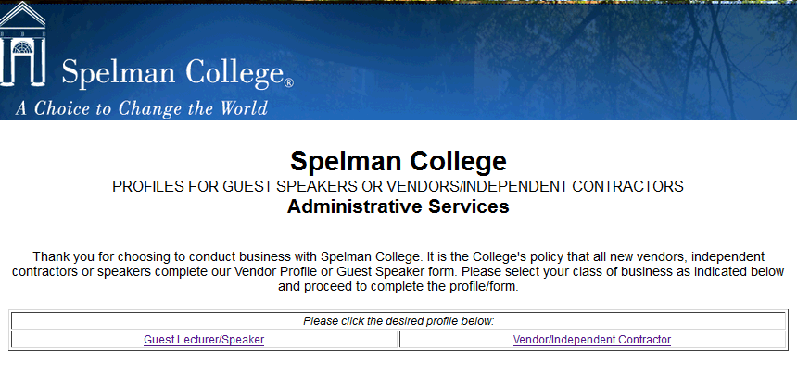

*Exhibit B (continued)*

*Vendor Profile Form/Guest Speaker*

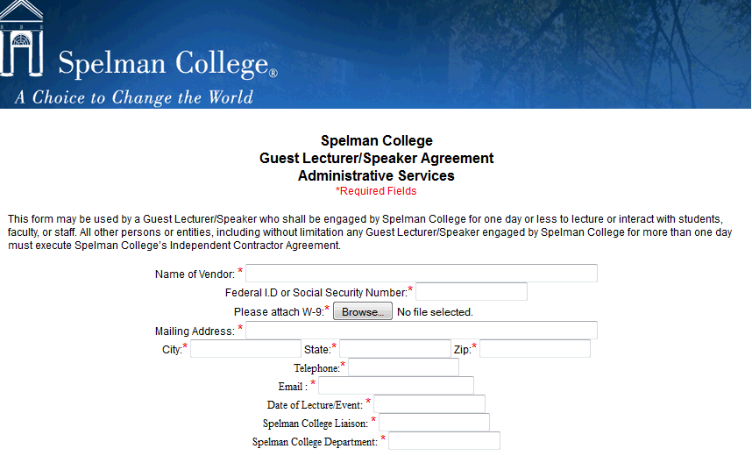

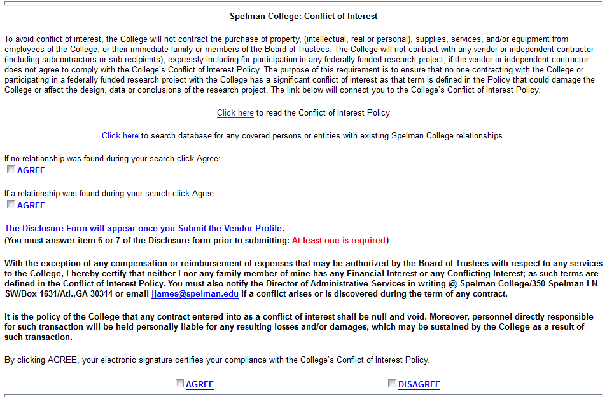

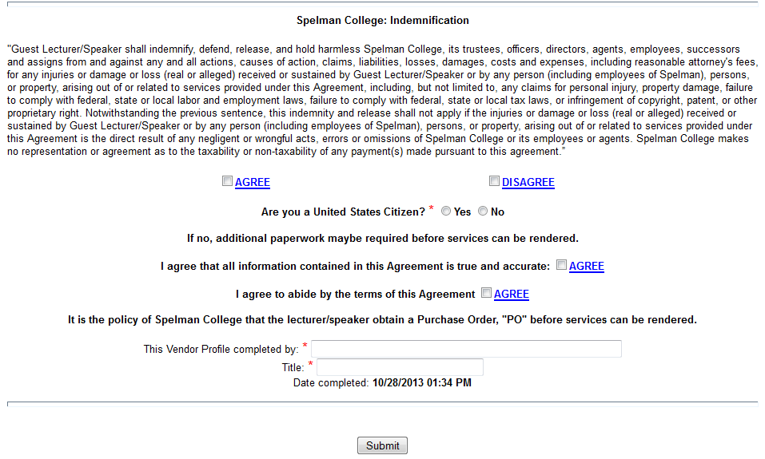

*Exhibit C*

***Spelman College Vendor Profile***

***Vendor/Independent Contractor***

***Administrative Services***

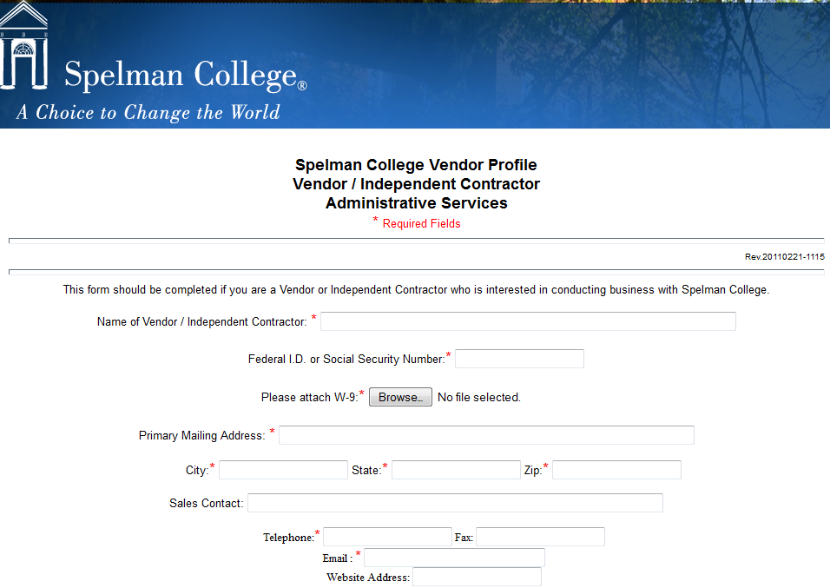

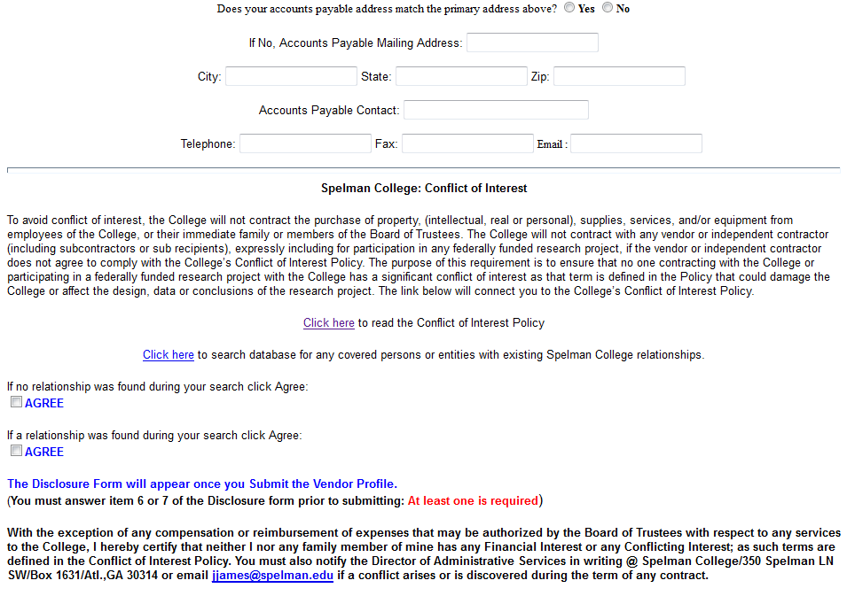

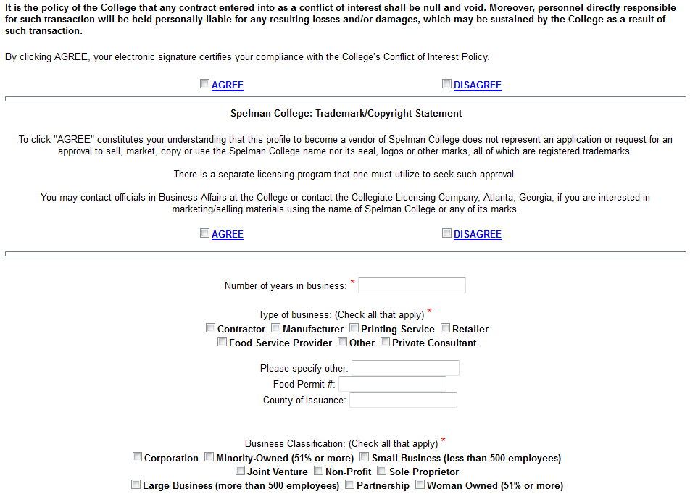

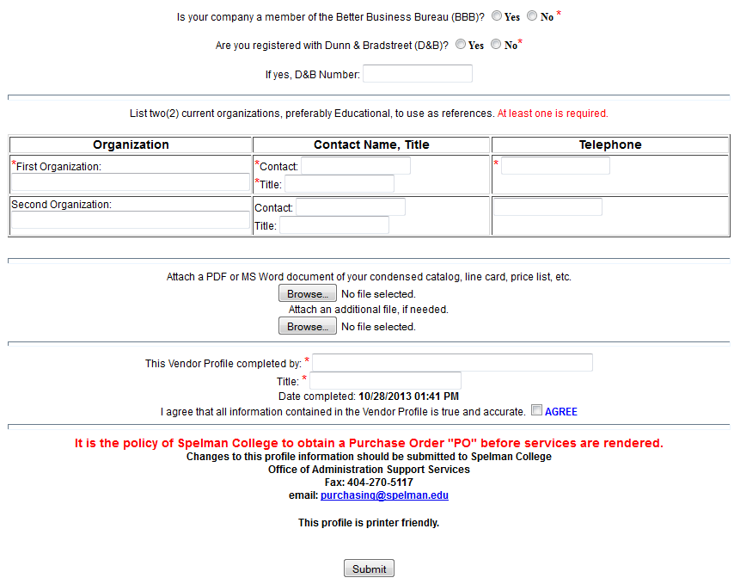

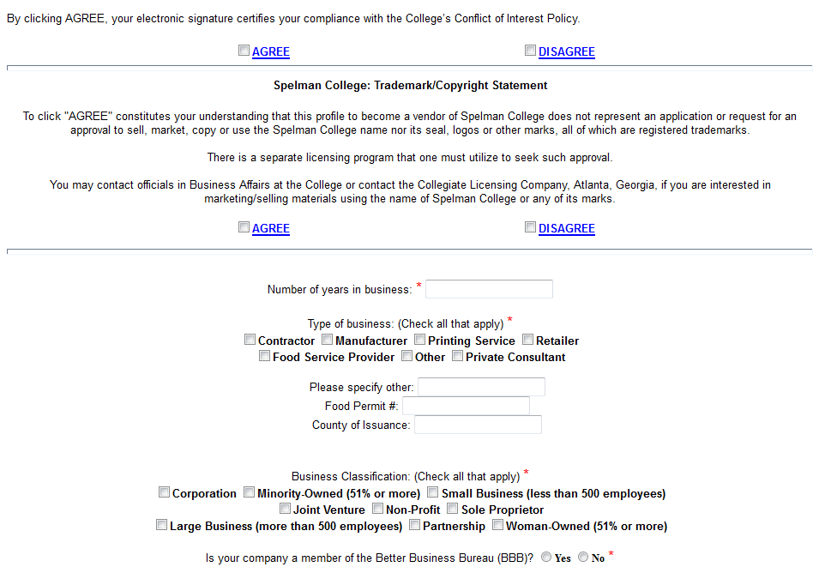***Exhibit D***

***Electronic Banner Requisition***

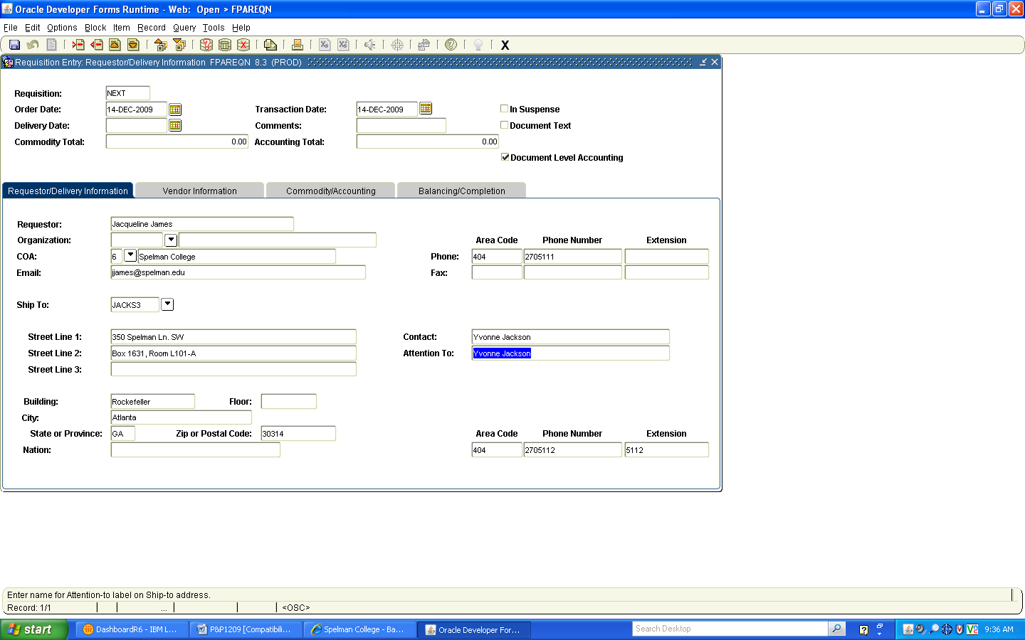

***Exhibit E***

***Purchase Order Example***

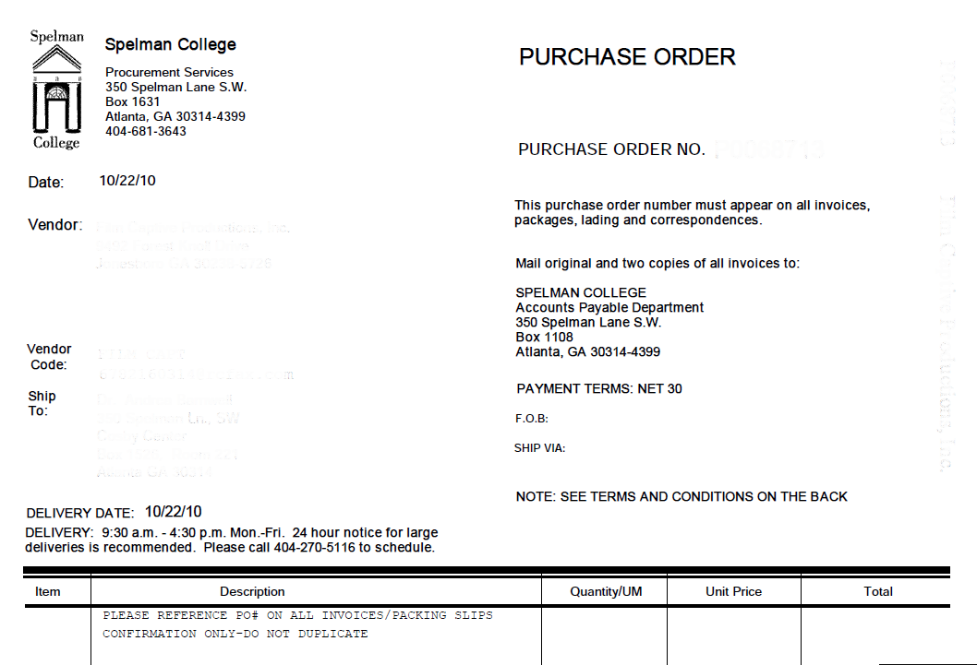

***Exhibit F***

***Motor Coach Policy***



**MOTOR COACH POLICY**

Spelman College has partnered with and identified motor coach vendors and ground transportation vendors (Limousine, mini bus, etc.) that meet or exceed all insurance requirements of our insurance carrier and the offices of the Vice President of Financial Affairs and Treasurer and Administrative Services.

It is Spelman’s policy that all Spelman departments and Spelman student groups use licensed motor coach vendors for transportation. Anyone that is not a Spelman College student or Spelman College employee is NOT covered under the Spelman College insurance policy.

It is policy to generate a requisition and acquire a purchase order before the trip. Vendors on the attached list will not proceed with the travel without a Spelman College purchase order. The only exception to this policy is travel via rentals.

If you should have any questions regarding Spelman’s Motor Coach Policy, please call Administrative Services at (404) 270-5115.

6/11

*Exhibit G*

*Product Licensing Policy*



**Product Licensing Policy**

Spelman College has partnered with Collegiate Licensing Company (CLC) to manage and maximize its licensing program. The Office of the Vice President of Financial Affairs and Treasurer oversees Spelman’s contract with CLC.

All vendors that use Spelman’s trademarks on merchandise (including t-shirts, caps, and all other saleable products) must be licensed. Vendors, who have access to the institution’s official digitized logos, are required to obtain approval through the licensing program on all designs and products that are produced bearing the College trademarks. CLC has licensed many local and national vendors for the production of Spelman merchandise.

It is Spelman’s policy that all departments and student groups use licensed vendors when purchasing products bearing the Spelman name or other associated marks. Spelman’s licensees adhere to the College’s licensing requirements by submitting all designs for approval.

All purchases for internal consumption or free distribution (i.e., products purchased for the exclusive use of a Spelman department or student group that are not resold for profit) are exempt from royalty obligations. All products, including those products for internal consumption or free distribution, must be purchased from a licensed vendor and all designs must be submitted by the vendor for approval.

If you should have any questions regarding Spelman’s trademark licensing program and its policies, please call **Administrative Services at (404) 270-5111**. If you need assistance in locating licensed vendors, please contact **Administrative Services at (404) 270-5113.**

7/09

***Exhibit H***

***Flowchart for the Procurement of Goods & Services***

**Employee of College Creates Requisition**

**Department’s Chairperson, Budget Manager, Provost, VP, or President Approves Requisition**

**Special Programs approves for Title III, NASA, MIE, MBRS, etc.**

**M.I.T approves for purchase of computers or peripheral equipment**

**Business Affairs reviews then approves or disapproves the requisition**

**Buyer receives the requisition to create the Purchase Order (PO) Number**

**Buyer processes PO and/or fax, email, from desktop to vendor, user, AP, and procurement**

**Note: If request is disapproved at any stage in the process, the requisition is returned to the requestor.**

***Exhibit I***

***Resource List***

###### SPELMAN COLLEGE

**Division of Business and Financial Affairs**

###### ADMINISTRATIVE SERVICES

**Resource Extensions**

**Director**

**404-270-5111**

**Procurement Manager**

**404-270-5113**

**Mail Center Manager**

**404-270-5858**

Administrative Services Coordinator

**404-270-5112**

**Buyer**

**404-270-5116**

**Project Coordinator**

**404-270-5115**

**Copy Services**

**404-270-5114**

**Telecommunications Operator**

**Ext 0**

***Questions regarding the check request process, contact the Controller’s Office at 404-270-5153.***

*Exhibit J*

***Independent Contractor Agreement***



This Agreement dated this________day of __________________________20______is between Spelman College,

350 Spelman Lane, Atlanta, Georgia 30314, (hereinafter referred to as the “College”) and_____________________

__________________________________________________ whose address for notices is _________________

_________________________________________________________, an independent contractor, hereinafter

referred to as the “Contractor,” whose Federal Employer Identification Number is:___________________________.

In consideration of the mutual promises contained herein, the College and Contractor agree as follows:

Article 1 - Services: The Contractor’s responsibility under this Agreement is to provide professional services as set forth in the Scope of Work detailed in Attachment “A” to this Agreement.

Article 2 – Schedule: The Contractor shall commence services on _______________________________20_____and complete all services by _____________________20______.

Article 3 – Payment:

A. The total amount to be paid by the College under this agreement for services and “out of pocket” expenses shall not

exceed __________________________________________________Dollars ($____________) without written modification to this Agreement. The Contractor will bill the College in accordance with the payment schedule set forth in Attachment “A” to this Agreement *only* for services rendered toward the completion of the Scope of Work. The College shall have no obligation to pay the Contractor until the Contractor submits reasonable evidence, in a manner satisfactory to the College, of completion of the work for which it is being billed. The College will not be obligated to pay for services billed but not rendered.

B. The College will reimburse Contractor within 30 days after receipt of a written invoice to the College with appropriate documentation of work performed. Invoices must reference the current purchase order number.

C. Out-of-Pocket” expenses will be reimbursed up to an amount not to exceed $_____________, and in accordance with the list of the types of expenditures eligible for reimbursement as outlined on Attachment “A” of this Agreement. All requests for payment of “out-of-pocket” expenses eligible for reimbursement under the terms of this Agreement shall include copies of paid receipts, invoices or other documentation sufficient to establish that the expense was actually incurred and necessary in performance of the Scope of Work described in Attachment “A” of the Agreement.

D. Agreements that will pay the Contractor $1000.00 or more will require fully executed signatures as detailed before the Agreement can be approved.

Article 4 – Independent Contractor Relationship: The Contractor is, and shall be, in the performance of all work services and activities under this Agreement, an Independent Contractor, and not an employee or agent of the College. All persons engaged in any of the work of services performed under this Agreement shall at all times, and in all places, be subject to the Contractor’s sole direction, supervision, and control. The Contractor shall exercise control over the means and manner in which it and its employees perform the work, and in all respects the Contractor’s relationship and the relationship of its employees to the College shall be that of an Independent Contractor and not as employees or agents of the College. The Contractor does not have the power or authority to bind the College in any promise, agreement, or representation other than specifically provided for in the Agreement.

**Individuals who are currently employed or who have been employed by the College within the past 12 months as staff, faculty, or student workers cannot be paid as independent contractors. These Individuals would have to be treated as employees.**

**DO NOT COMPLETE OR SUBMIT THIS FORM FOR APPROVAL IF THE AFOREMENTIONED APPLIES.**

Article 5 – Liability: The Contractor shall not commence work under this Agreement until it has shown proof of the following (minimum) insurance requirements.

Comprehensive General Liability Insurance (Minimum limit of $1,000,000)

Workmen’s Compensation Insurance in an amount adequate to cover legal requirements for all its employees in accordance with laws of the State of Georgia

Article 6 – Indemnification: The Contractor shall indemnify and save harmless and defend the College, its agents and employees from and against all claims, liability and loses, which may arise from any act or omission of the Contractor, its agents, or employees in the performance or services under this agreement.

**ATTACHMENT “A” TO INDEPENDENT CONTRACTOR AGREEMENT**

Requisition Number:________________________________

1. CONTRACTOR:

____________________________________________________________________________________

(NAME)

____________________________________________________________________________________

(STREET)

____________________________________________________________________________________

(CITY, STATE, ZIP CODE)

Telephone #: (_______) _______ - ________________

II. Scope of Work: Attach additional pages (including PO reference) if necessary_______________________

_______________________________________________________________

_______________________________________________________________

_______________________________________________________________

_______________________________________________________________

_______________________________________________________________

III. Rates and/or Payment Schedule__________________________________________________________

_______________________________________________________________

_______________________________________________________________

“Out-of-Pocket” Expenditures are restricted to the following expense item: _________________________

____________________________________________________________________________________

IV. Key Personnel Assigned to Project (Resumes may be required in some instances):

__________________________________________SSN/ID#___________________________________

(Print)

__________________________________________SSN/ID#___________________________________

(Print)

__________________________________________SSN/ID#___________________________________

(Print)

Contractor’s Signature:________________________________________________Date:_____________________

Spelman Representative:______________________________________________ Date:_____________________

Article 7 – Confidentiality: All business information or other confidential or proprietary information that may come into the possession of the Contractor while performing work under this agreement shall be treated as confidential. Contractor agrees to take strict precautions against disclosure of such information to third parties during and after the term of the agreement. This obligation of confidentiality shall survive for 5 years following the completion of Contractor’s services.

Article 8 – Ownership of Work Product: All right, title, and interest in and to any invention, work product, idea or creation conceived, developed or produced during the performance of services under this Agreement (including but not limited to creative, copy, scripts, story boards, writing, copyrights, trademarks, art, music, software and documentation, business systems or ideas, and research projects) shall be property of the College whether created individually by the Contractor or jointly with the College, on or off premises. Contractor also warrants that all material, including musical, literary or artistic work that is furnished to the College pursuant to this Agreement may be used and reproduced for any purpose whatsoever, including advertising, promotion and trade purposes, without violating the personal or property rights or any persons and without infringing any copyright, trademark or patent.

The Contractor hereby assigns to the College any and all rights, title and interest in work performed by the Contractor under this Agreement, and to any proprietary rights and intellectual property rights in such work.

Article 9 – Termination: This agreement may be terminated with thirty (30) days’ prior written notice to the other party at the appropriate address given above, or designated by a party in writing. In the event of such a termination, the Contractor shall be paid for all proper work performed up to the termination date.

Article 10 – Record Retention and Access:

Any and all records pertaining to the contracted project (i.e. invoices, receipts, intellectual property, etc), must be readily accessible to the Contractor and retained three (3) years after the end of the contract. If this contract is funded by federal dollars, pursuant to federal regulations, all records must be additionally readily accessible to the granting agency.

This agreement shall be governed and construed under the laws of the State of Georgia.

I have read this agreement prior to signing:

CONTRACTOR SPELMAN COLLEGE

Date:_______________________________ Date:_______________________________

_______________________________________ ____________________________________

(Signature) Budget Manager

___________________________________________ _________________________________________

(Vendor Name) Provost/Div. VP

___________________________________________ _________________________________________

(Vendor Address) Administrative Services

___________________________________________ _________________________________________

(Vendor City, State & Zip Code) VP or Assoc. VP for

Business and Financial Affairs

***Exhibit K***

*The Check Request Process*

Check Request

Check Requests are used to request payments for any goods, services, or other miscellaneous payments that are not covered by a purchase order. Check Request must be approved by the department head or delegate. Heads of departments and administrative units may not approve their own Check Requests. Approval of a Check Request indicates that authorized goods and services were received or an authorized service or travel was performed or completed. The approval authorizes the Controller’s Office to pay vendors for goods or services received, reimburse employees, and charge the accounts indicated, provided funds are available. Additional approvals may be necessary when grant funds are being utilized. Appropriate supporting documentation includes original receipts for items purchased, and original invoices for payment.

Because Spelman College operates on a purchase order system, all requests for goods and services must be transacted through the purchase order process. The check request method of payment will be limited to the College’s weekly and/or monthly obligations such as utilities, dues and subscriptions, salary and travel advances, and expense reimbursements. Expenditures for goods and services submitted on a Check Request form, which should have been purchase through the purchase order process, will be returned to the requester. All Check Requests will be systematically processed. If the check request is denied by any authorizing personnel, the Check Request will be returned to the requester along with an explanatory letter.

The process for submitting a check request is outlined below:

1. The requester must check the availability of funds for payment of a Check Request prior to submitting the Check Request to the Office of the Controller, Accounts Payable Office. If the system indicates funds are not available, the Check Request will be returned to the sender indicating that funds are not available.
2. To be processed expeditiously, a Check Request must be completed accurately. Each completed Check Request form must contain the following:

* Budget Code
* Requester’s name, phone extension, and campus mailbox number
* Remittance address
* Social security number for individuals being paid by the College
* Approval of department’s chairperson or appropriate personnel
* Check the appropriate boxes for check distribution.

***Exhibit L***

***DISPOSITION OF FIXED ASSETS***

**Disposition of Assets – Movable Equipment**

**The Controller’s Office is responsible for changing the status of records when the disposition of assets occurs. In general, surplus or obsolete equipment may be disposed of by transferring to another department, discarding/scrapping, trading-in, donating, or selling the asset. When selling, donating, trading-in or discarding/scrapping of assets, the department responsible for the asset must complete the Property Movement Form (located on the Lotus Notes Dash Board under the Business & Financial Affairs Category - Controller’s Office Applications – Submit a New – Inventory Change). This form should be sent to the Controller’s Office as notification to dispose of the asset.** The Associate Vice President for Business and Financial Affairs **must approve the disposition of the asset by signing the Property Movement Form and returning it to the Controller’s Office. The Controller’s Office will retain a copy and send a copy of the form back to the department with the appropriate signatures so that they may proceed with the disposition.**

When disposing of assets, the College reserves the right to determine the method of disposal. In determining the method of disposal, the College will take various factors into consideration, including, but not limited to, the age, condition and the nature of the assets being disposed of. The College, at its option, will dispose of assets either through a bidding process, with a minimum of 2 bids being solicited or a general sale where the College reserves the right to establish a minimum price for the assets.

Upon completion of all dispositions, the department responsible for the asset must submit documentation confirming the disposal including a description of the asset, disposal date, sale/trade-in value, and any other pertinent details. Disposing of an asset requires removing the asset's net book value from the accounting records. This involves removing the original cost and the accumulated depreciation of the asset. Any difference between the proceeds received and the net book value represents a gain or loss on the disposal of the asset which will be recorded by the Controller’s Office upon completion of the disposition.

**Movement of Assets – Movable Equipment**

**In the event an asset is to be moved from one location to another or from one department to another a Property Movement Form must be completed and submitted to the Controller’s Office.**

**Once the form has been received by the Controller’s Office, the College’s fixed asset records will be updated with the change. Submitting this form will ensure that inventory listings provided to the Departments are accurate.**

# PP&E Custodian’s Responsibilities

Each department head has direct responsibility for PP&E used by their respective department.

1. Each department head is responsible for the accuracy of the property records. This includes reporting any location change, planning and obtaining proper maintenance, and creating the annual capital budget for the department.
2. Each department will implement adequate safeguards to prevent loss, damage or theft of assets. Any loss, damage or theft of assets shall be investigated and fully documented. Stolen equipment should be reported to the College’s Public Safety Department immediately. A copy of the police report detailing the theft should be sent to the Controller’s Office. If the federal government owned the asset, the Controller’s Office shall promptly notify the federal awarding agency.
3. Adequate maintenance procedures are required to keep all assets in good condition.
4. The use of College equipment by individuals or organizations for activities not directly connected with the College is prohibited. College owned or controlled equipment shall not be removed from the College’s premises except in cases where such equipment is to be used in the line of official duty.
5. The use of College vehicles is restricted to official College business.

# Purchasing Department Responsibilities

Each individual item, purchased and valued at $5,000 and above, will be logged and tagged by the purchasing department.

# Controller’s Office Responsibilities

The Controller’s office will maintain the inventory of all moveable and stationary equipment and real property for which the College is accountable. The fixed asset records shall be maintained accurately and shall include the following information:

1. A description of the property and equipment
2. Manufacturer’s serial number, model number, Federal stock number, national stock number or other identification
3. Source of the property and equipment, including the award number (grant)
4. Whether title vests with the College or the Federal government
5. Acquisition date
6. Purchase price or acquisition cost
7. Location and condition of the property and equipment and the date the information was reported
8. Ultimate disposition data, including date of disposal and sales price or the method used to determine current fair market value where a recipient compensated the federal awarding agency for its share
9. Property class such as building, equipment, vehicle, computer etc.
10. Method of depreciation. The College generally uses the straight-line method of calculating the depreciation.

Federal Guidelines

The Federal Government and its agencies have established guidelines for both Government-owned property and property acquired with federal funds, whether titled with the government/agency or with the College.

Assets Purchased with Federal Funds

All equipment purchased with Federal funds must be necessary and reasonable for proper and efficient accomplishment of project or program objectives. In addition, the Department Head/Principal Investigator is responsible to ensure that duplicate or unnecessary purchases are avoided. Award documents may include clauses that specify both the authorization required for purchasing equipment and with whom the title vests.

Contractual agreements governing some grants or contract funds and acquisitions from federal grants require the capitalization of items not meeting the College’s property guidelines. In this case, the agreement conditions of the grant will prevail over the College policy.

Control Procedures

In addition to the normal control procedures required for College-owned property, the following controls are required for Federal-owned property:

* + 1. Federal-owned property must be carefully monitored and in many cases reported annually.
    2. In addition, Federal property shall be identified, tagged and recorded during the receiving process to indicate federal ownership.
    3. Property records systems must contain the prescribed data categories as established by Federal Acquisition Regulation (FAR) 45.505.
    4. Movement of Federal property must be documented so that records are updated to show changes in quantities and location.
    5. Inventories of Federal property shall be performed at least once per year, based on the requirements of the award documents.

Disposal/Transfer of Federal-Owned Assets

At the completion of a grant or contract, disposition of all Federal-owned property acquired for the grant or contract must occur. It is possible that the property may be sold, transferred to be used by another grant at the College, or title may be transferred to the College. The appropriate Federal agency personnel must approve any transfer of Federal-owned property before the transfer occurs. In addition, when required, the appropriate transfer forms should be completed. Where the College is authorized or required to sell the equipment, proper sales procedures shall be established which provide competition to the extent practicable and result in the highest possible return to the Government.

If the College needs to use the equipment for non-federal contracts, then the College shall reimburse the Federal agency for amounts, as they would pay for non-federal contracts.

If the College does not have a need for the equipment, then this shall be reported to the awarding agency. The College may be instructed to ship the equipment to another entity, dispose of the equipment, or transfer title to the federal government or to a third party.